**LAMPIRAN D**

**DATA**

**ADMINISTRASI WILAYAH MANDAILING NATAL**

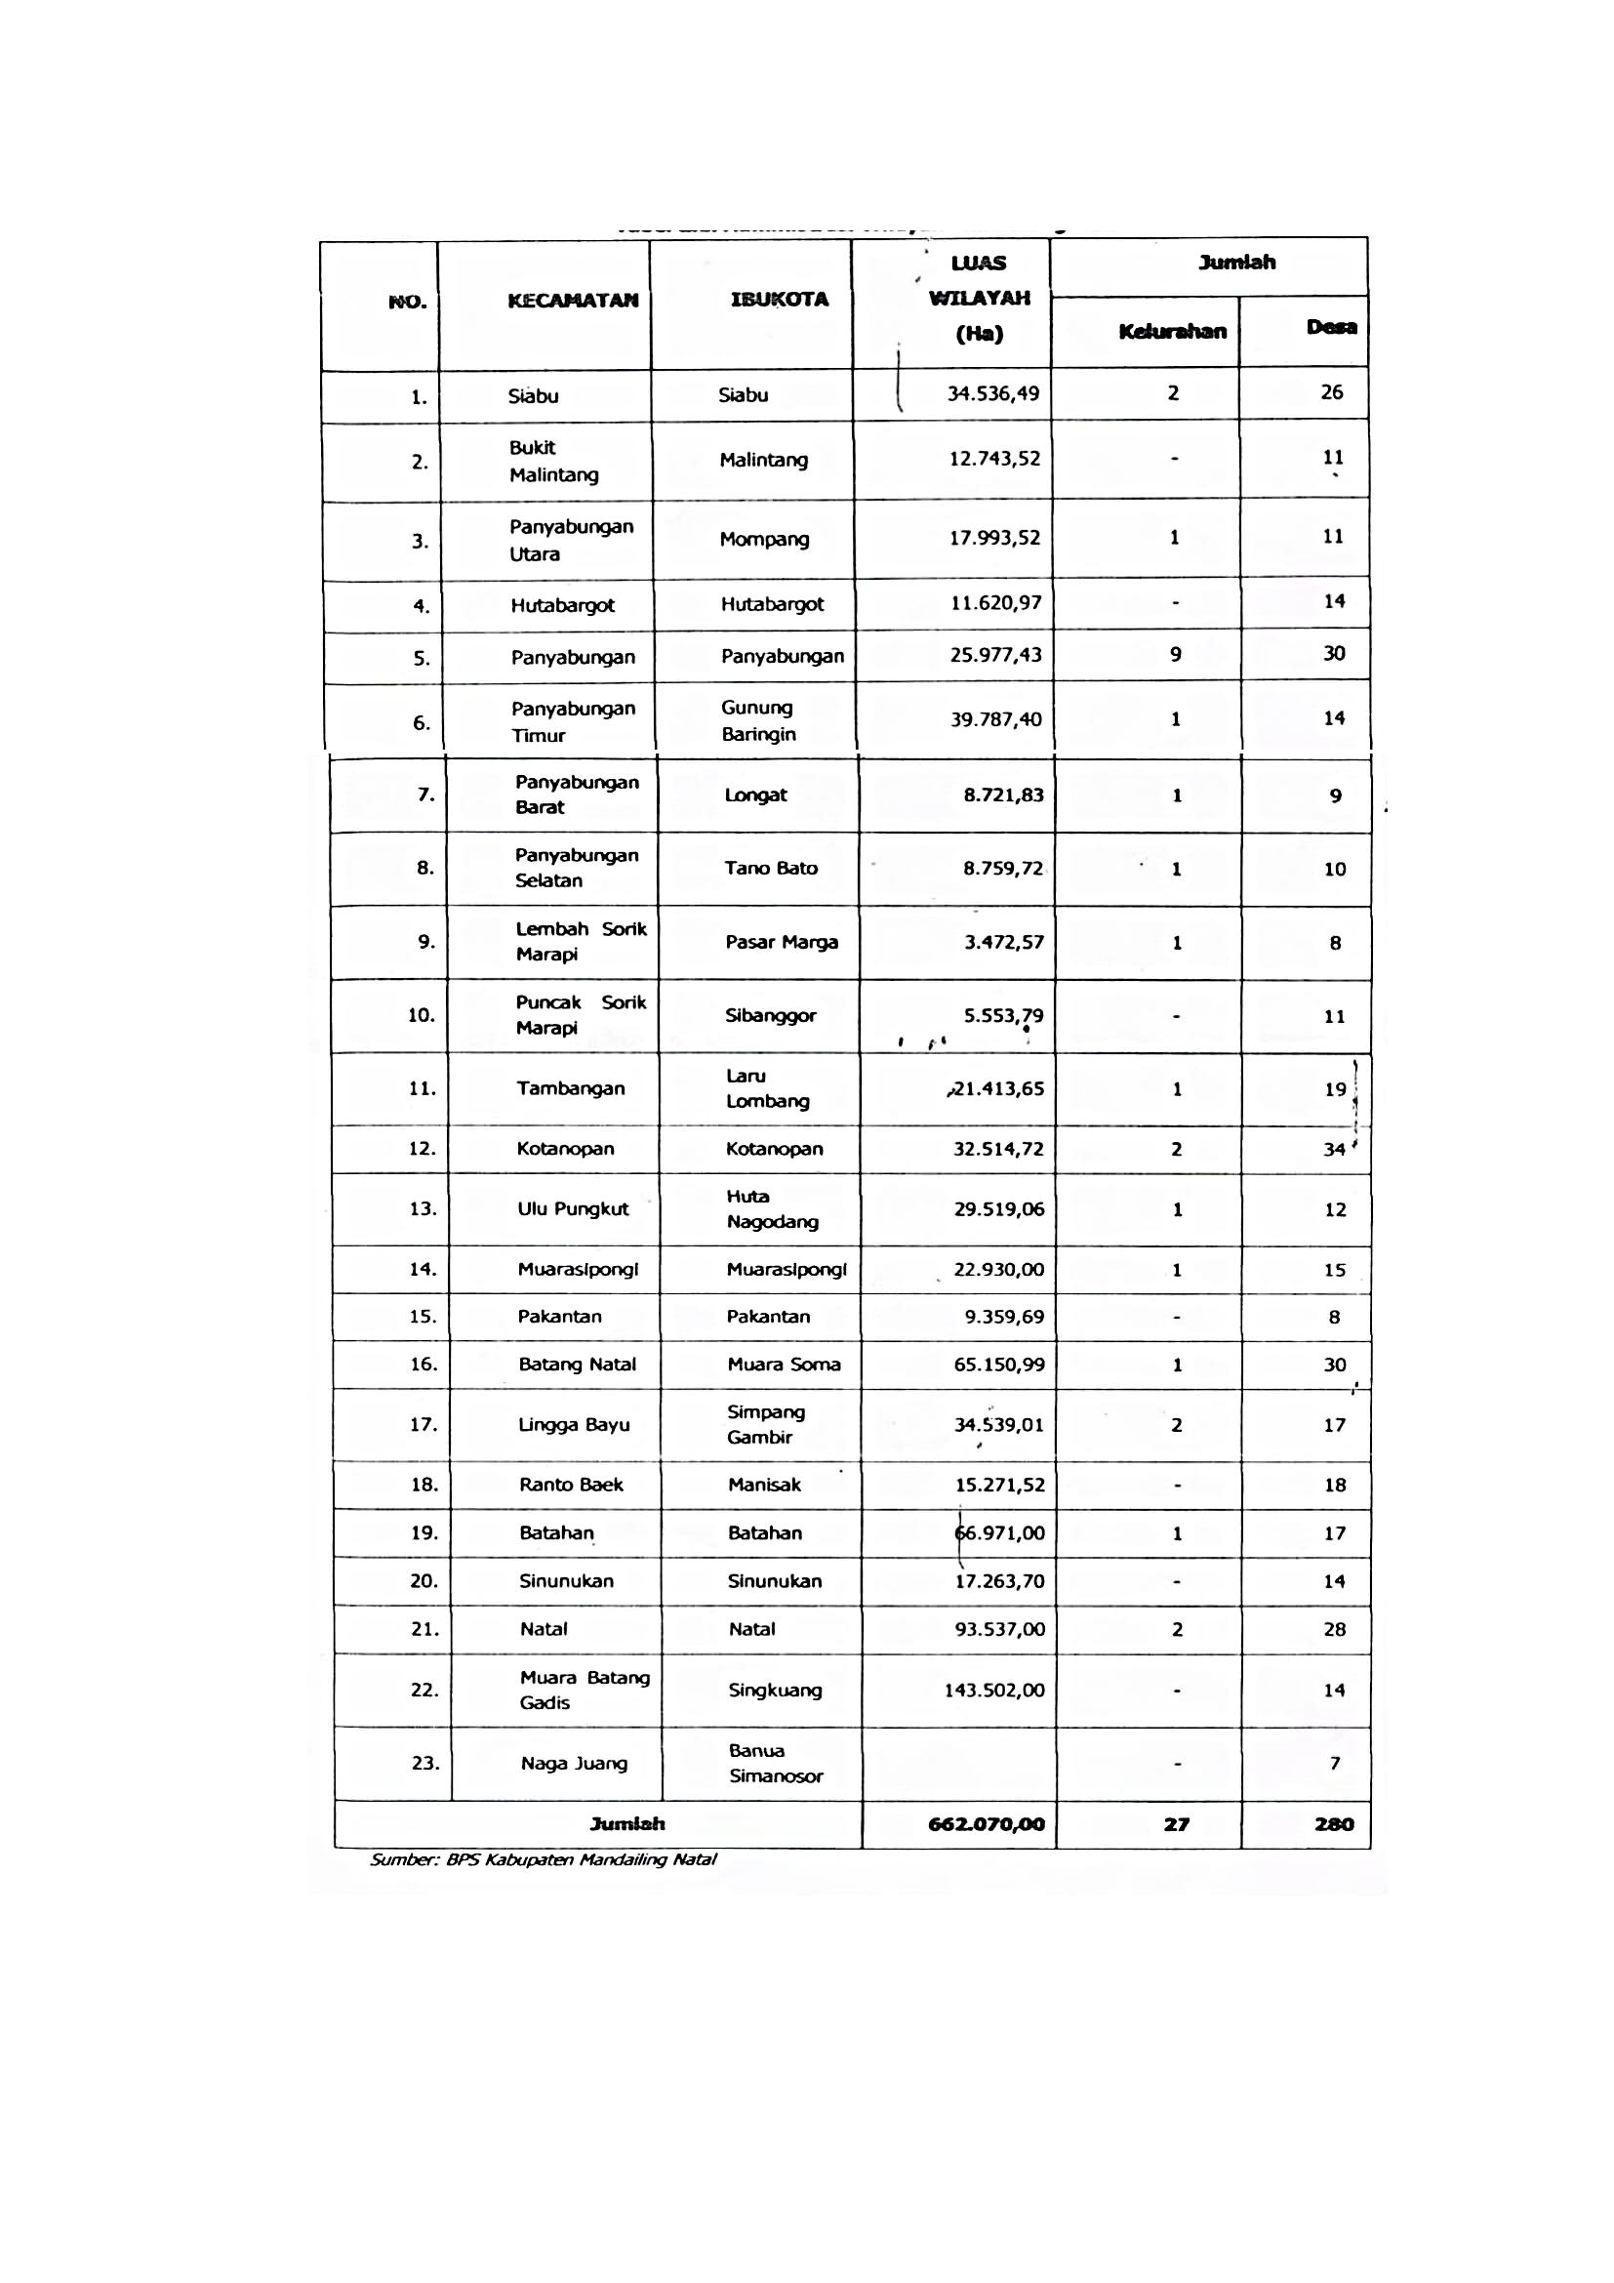

|  |  |  |  |  |  |  |
| --- | --- | --- | --- | --- | --- | --- |
| **Panjang Jalan Kabupaten Menurut Konstruksi**  **Permukaan Jalan dan Kecamatan Length of Regency Road by Road Surface Construction and District** | | | | | | |
| **2015*) (Km)** | | | | | | |
| **Kecamatan   District** | **Konstruksi Permukaan Jalan Road Surface Construction** | | | | | **Jumlah Total** |
| **Baik Good** | **Sedang Fair** | **Rusak Bad** | **Rusak Berat Very Bad** | |
| **[1]** | **[2]** | **[3]** | **[4]** | **[5]** | | **[6]** |
| **1. Batahan** | 1,10 | 0,00 | 0,00 | 76,90 | | 78,00 |
| **2. Sinunukan** | 26,80 | 0,00 | 6,00 | 39,20 | | 72,00 |
| **3. Batang Natal** | 5,29 | 1,70 | 29,30 | 82,50 | | 118,79 |
| **4. Lingga Bayu** | 14,20 | 0,00 | 18,30 | 42,10 | | 74,60 |
| **5. Ranto Baek** | 2,00 | 0,00 | 0,00 | 44,40 | | 46,40 |
| **6. Kota Nopan** | 34,05 | 0,00 | 26,69 | 92,34 | | 153,08 |
| **7. Ulu Pungkut** | 10,00 | 0,00 | 10,00 | 44,00 | | 64,00 |
| **8. Tambangan** | 11,74 | 0,00 | 24,16 | 23,00 | | 58,90 |
| **9. Lembah Sorik Marapi** | 20,80 | 1,20 | 0,90 | 11,30 | | 34,20 |
| **10. Puncak Sorik Marapi** | 5,21 | 0,00 | 1,60 | 12,19 | | 19,00 |
| **11. Muara Sipongi** | 16,00 | 4,00 | 10,50 | 12,68 | | 43,18 |
| **12. Pakantan** | 7,52 | 0,00 | 15,50 | 37,48 | | 60,50 |
| **13. Panyabungan** | 46,22 | 4,83 | 10,55 | 61,40 | | 123,00 |
| **14. Panyabungan Selatan** | 0,43 | 0,00 | 9,40 | 24,17 | | 34,00 |
| **15. Panyabungan Barat** | 2,15 | 0,00 | 4,75 | 32,20 | | 39,10 |
| **16. Panyabungan Utara** | 17,50 | 2,63 | 20,17 | 0,00 | | 40,30 |
| **17. Panyabungan Timur** | 20,74 | 7,50 | 15,46 | 27,50 | | 71,20 |
| **18. Huta Bargot** | 24,88 | 0,00 | 17,12 | 1,50 | | 43,50 |
| **19. N a t a l** | 12,94 | 11,00 | 18,37 | 117,54 | | 159,85 |
| **20. Muara Batang Gadis** | 6,00 | 0,00 | 4,00 | 193,00 | | 203,00 |
| **21. S i a b u** | 42,05 | 1,00 | 20,97 | 66,65 | | 130,67 |
| **22. Bukit Malintang** | 7,53 | 0,50 | 16,77 | 5,80 | | 30,60 |
| **23. Naga Juang** | 1,50 | 0, ,00 | 15,50 | 20,00 | | 37,00 |
| **24. Jalan Dalam Kota Ibu Kota Kabupaten** | 67,19 | 1,89 | 26,80 | 3,62 | | 99,50 |
| **Mandailing Natal** | **403,84** | **36,25** | **322,81** | **1 071,47** | | **1 834,37** |
| Sumber : Dinas Pekerjaan Umum Kab. Mandailing Natal  *) Masih menggunakan data 2015 karena data 2015 tidak tersedia | | | | |

|  |
| --- |
|  |
|  |